“Comparative and Hybrid Machine Learning–Deep Learning Approach for Student Mental Stress”

Bantu Vyshnavi
Dept. of Computer Science and Artificial Intelligence SR University, Warangal-506371, Telangana,India
vyshnavi.bantu05@gmail.com

Abstract:
Mental stress among students is increasingly seen as a problem that consists of Academic, social and lifestyle factors at its root. A breakthrough study signals the way to a hybrid Machine Learning and Deep Learning (ML–DL) approach that will be able to predict and classify student stress levels. Survey and behavioral data will be the basis to compare traditional ML models like Random Forest and SVM along with DL models like ANN and LSTM. The hybrid framework is the union of ML’s feature selection prowess and DL’s adaptive learning that turns predictions into a more accurate one. The experiments prove that the hybrid model has a better accuracy and reliability than individual models, thus providing an effective means for early stress detection and monitoring of student mental health.
Keywords: Student Mental Stress, Machine Learning, Deep Learning, Hybrid Model, Stress Prediction, Random Forest, SVM, ANN, LSTM, Mental Health Monitoring, Data Analysis, Educational Institutions

I. Introduction
  - A. Background and Motivation

Mental health issues have for sure been treated with kids and adolescents in educational institutions and this is because the students are exposed to more and more stress, coming from academic pressure, competition, and social expectations. Besides, chronic stress causes a range of mental and emotional problems (e.g., anxiety, depression) as well as dropouts, thus it is very important to utilize early detection and intervention measures. Among these methods, traditional ones such as surveys and direct counseling are still widely employed. However, they are often thought of as subjective, time-consuming, and having a limited scope. Thanks to the rapid growth of artificial intelligence, the machine learning (ML) and deep learning (DL) techniques have gotten very fruitful in the area of mental health prediction by their ability to analyze the data that is complex and given in different forms such as behavioral and physiological data. The ML algorithms are best at the feature selection and classification, while the DL models are good at capturing the non-linear relationships and temporality in the data. But using either technique alone may not fully reflect the different aspects of the stress that students go through. Consequently, the current version of the research has proposed a comparative and hybrid machine learning to deep learning model that leverages the advantages of both approaches to more accurately predict and classify the stress levels of students. The underlying reason for this endeavor is to create a system that is powered by data, efficient, and trustworthy, and one that would also help the teachers and the counselors to spot the kids who are likely to be in trouble very early and give them the support they need in a timely manner so that the overall well-being gets better.

  - B. Requirement Advanced Forecasting Models

The requirements of the system proposed analysis on the need to recognize major parts that would lead to an appropriate mental stress forecasting model for students. The use of the Machine Learning (ML) and Deep Learning (DL) algorithms as the core of the system has been indicated, which will enable to detect and classify the stress levels accurately by utilizing various data sources.Data inputs from the schools, students’ top five lifestyle habits, behavior patterns, and students’ survey reports are all to be collected to complete the system’s backend. These data sources will then form the predictive model base from which the various factors that influence the mental well-being of the students will be gradually uncovered through data mining techniques. The functional requirements of the proposed system include data preprocessing, feature extraction, model training, and performance comparison. Data preprocessing step takes care of and maintains data quality by treating missing values and inconsistencies and filtering noise through appropriate methods. Different ML models like Random Forest and Support Vector Machine (SVM) are trained along with DL models such as Artificial Neural Network (ANN) and Long Short-Term Memory (LSTM) to find out the best algorithm for stress prediction. After this, the best-performing models will be combined in a hybrid ML–DL framework that will utilize the benefits of both methods. The prediction outcomes will be presented to the institutions clearly through the help of the visualization and report generation departments. The non-functionals guarantee that the system will be executed in an eco-friendly and secure manner. It needs to be able to deliver particular results at high levels of precision and recall and to learn working with big data and also be scalable and at the same time to have the highest data confidentiality because mental health information is very sensitive. The system should also provide a user-friendly interface that can be operated easily by the educational staff, thus making the staff-system interaction more efficient.

  - C. Role of Hybrid Modeling
The hybrid modeling in stress prediction systems for students is the major factor that enhances precision, flexibility, and integrity. For instance, the classic machine learning (ML) techniques apply mainly to algorithms like Random Forest (RF), Support Vector Machine (SVM), and Logistic Regression, which are particularly strong in feature selection, pattern recognition, and the processing of structured data. Unfortunately, these models are usually not able to understand complex, non-linear interactions and temporal dependencies occurring in behavioral or physiological datasets comprehensively. In contrast, the Deep Learning (DL) category like Artificial Neural Network (ANN) and Long Short-Term Memory (LSTM) networks offer a powerful tool capable of capturing even the intricacies and the order of the events in the data, however, they are almost impossible to work with because they need enormous datasets and the cost of computation is very high.
Hybrid modeling is doing exactly that in the mixing of ML and DL which takes the best of both worlds and compensates for the individual weaknesses. ML models are very fast in detecting the relevant features and applying dimensionality reduction techniques, thus they provide input for DL models that are already very sophisticated and abstract. This integration leads to prediction accuracy increase, better generalization, and more stress patterns among students being interpretated easily. As far as mental health of students is concerned, hybrid modelling will allow the system to process data of different types, such as academic performance measures, level of social interaction, sleep data, and indicators of emotional states, in a far more efficient way. In addition, the hybrid model does not only allow detecting stress at a young age but also encourages constant learning as the availability of more information increases. In conclusion, this solution presents a well-rounded, data-driven solution capable of making predictions about stress patterns and help educational centers implement preventive actions in the treatment of mental health issues.

  - D. Research Contributions
The proposed study makes it possible to detect and forensically analyze mental stress in students early, which is achieved by applying a combined Machine Learning -Deep Learning (ML-DL) model that combines the benefits of both ML and DL. The suggested architecture employs the power of ML algorithms like Random Forest and SVM to select the features and the deep learning models like ANN and LSTM to identify patterns. An ML vs. DL comparative study is carried out not only to understand the difference in performance among the two methods but also to point out the combinations that are most effective for stress prediction. The model employed a composite dataset consisting of academic, behavioral and lifestyle factors to ensure that the results are realistic and accurate. The hybrid approach performed with better accuracy, precision and interpretability providing a practical yet data-driven solution for the educational institutions to keep a check on their student's mental health and thus, timely intervention.

  - II. Literature survey
There is a big number of studies which have reported that the combination of Machine Learning (ML) and Deep Learning (DL) techniques can be used to anticipate mental stress in students and the general population. Among others, Random Forest and SVM have been named as traditional ML models that through the usage of academic, behavioral, and physiological data, have considerably classified stress levels. However, their limitations regarding complex and nonlinear relationships are usually noted. On the other hand, Deep Learning models such as CNN and LSTM have the ability to effectively capture temporal and high-dimensional patterns in stress-related data, but they require large datasets and higher computational power. Recent studies highlight hybrid ML-DL solutions that feature selection strength of ML and the adaptive learning capability of DL, thus achieving improved accuracy and reliability. Apart from these hybrid models, the detection of student mental stress has shown great potential, enabling educational institutions to take timely preventive measures.
A. Traditional approaches for student mental stress
Predicting the psychological stress of students using traditional methods has primarily been backed by Machine Learning (ML) methods like Support Vector Machine (SVM), Random Forest (RF), Decision Tree (DT), and Logistic Regression (LR). By utilizing the models, stress levels are classified based on the features that are manually extracted from academic performance data, surveys, and behavioral patterns. They work best with structured datasets and, as a result, provide good interpretability along with moderate accuracy. Nonetheless, their performance is, in most cases, inferior to that of large, unstructured, or time-dependent datasets as they are unable to efficiently interpret deep and nonlinear connections among stress-related factors. Even with the above-mentioned drawbacks, traditional ML models are still able to present strong baselines for comparison and are essential for the feature selection process in more advanced hybrid frameworks..
B. machine learning applications in student mental stress prediction
Machine Learning (ML), an advanced technology, has come a long way in a very short time and has now taken a very active role in analyzing and predicting student mental stress by uncovering the patterns that were hidden in the academic, behavioral, and physiological data. ML models such as Support Vector Machine (SVM), Random Forest (RF), K-Nearest Neighbor (KNN), and Logistic Regression (LR) classify the students into different levels of stress according to various inputs like academic performance, attendance, social engagement, sleep duration, and self-reported surveys. Moreover, these models help the institutions by detecting the stress trends early, which means they can provide timely counseling and intervention. Besides, ML feature selection has assisted in determining the most influential stress factors thus aiding data-driven decision making in educational environments. No doubt about it, ML applications are the ones who have turned the whole process from subjective stress assessment to an objective, automated, and predictive one.
C. ensemble learning applications in student mental stress
Utilizing various ensemble learning techniques has led to the development of reliable and accurate forecasting tools for student mental stress as they primarily rely on the strengths of several individual models. Amongst others, Random Forest, Gradient Boosting, AdaBoost, and XGBoost are the algorithms that take the combined outputs of several base learners to help with the risk of overfitting and performing better with unseen data. In the case of student stress analysis, ensemble models work with different data sources—academic records, behavioral indicators, and physiological signals—where extracting of complex, nonlinear relationships that are the factors of the stress levels takes place. By making use of the cooperation among classifiers, these models are able to render predictions that are more stable and accurate. Hence, the application of ensemble learning is considered to be a key step in the direction of creating forecasting systems that are not only able to monitor student well-being but also support the implementation of proactive mental health interventions in schools.
d. explainable ai in student mental stress
Explainable Artificial Intelligence (XAI) is a crucial factor in providing the transparency and reliability of AI models that are applied in predicting student mental stress. On the other hand, complicated Machine Learning and Deep Learning models are somehow placed on the same level with high accuracy and their decision-making procedures are still called “black boxes", so that educators or psychologists can hardly perceive the reason for a specific student to be noticed as stressed. The XAI system solves this problem by granting interpretable insights on the role of different factors—like sleep patterns, academic performance, attendance, or social activity—on total stress levels. The techniques, for instance, SHAP (Shapley Additive Explanations), LIME (Local Interpretable Model-agnostic Explanations), and feature importance analysis do a great job in the visual representation of and justification for the model predictions. XAI, by giving clarity and justification for the AI-driven results, makes it possible to have ethical, transparent, and responsible technology use in educational mental health monitoring, thus allowing counselors and administrators to intervene in an informed and empathetic manner.e. advanced machine learning and deep learning techniques.
The application of Advanced Machine Learning and Deep Learning techniques has resulted in the prediction and analysis of student mental stress to the next level by providing more accurate, adaptive, and data-driven insights. The adoption of modern ML algorithms like Gradient Boosting, XGBoost, and LightGBM, which can be regarded as a change in paradigms, has been seen to result in very satisfactory performances through the combination of numerous weak learners for efficient handling of the high-dimensional, complex datasets involved. These aforementioned models are very good at detecting the very subtle correlations among the factors such as academic, behavioral, and psychological that influence the stress levels. On the contrary, the Deep Learning (DL) methods like Convolutional Neural Networks (CNN), Recurrent Neural Networks (RNN), and Long Short-Term Memory (LSTM) tend to focus on extracting the temporal and nonlinear patterns in the case of sequential or sensor-based data that includes heart rate, sleep cycles, and activity logs. Not only that, but also the power of advanced hybrid approaches that combine the interpretability of ML with the learning capability of DL gets one step closer in making the predictions accurate and more generalizable. Hence, these advanced techniques have been stacked up as the pillars for the establishment of smart and automated systems that will not only predict but also take care of the mental stress of students very efficiently..

III. Dataset Overview
The study is built on a dataset that consists of 1100 student records, each one characterized by a comprehensive collection of numerical features that jointly reveal the influencers of mental stress from academic, psychological, behavioral, and social perspectives. These features contain variables like anxiety levels, depression indicators, study hours, quality of sleep, performance in academics, social support, and other psychosocial factors that are often perceived as the major contributors to stress among students in the educational environment. The dataset is completely populated with no missing values, thus offering a clear basis for exploratory analysis and machine learning workflows that do not require imputation strategies. The initial statistical check reveals that some psychological variables have moderate skewness, which means that there is natural variability in the mental health status of students, while the academic and lifestyle-related features have a more uniform distribution throughout the dataset. The correlation analysis finds strong linear relationships between mental health indicators and stress outcomes, which are consistent with previous psychological research, and suggests that the use of hybrid ML-DL modeling could yield highly predictive results. The use of IQR and z-score methods for outlier detection reveals a small number of extreme cases, mainly in the areas of anxiety, depression, and sleep-related issues, which can be considered as genuine high-risk cases rather than noise but still need to be monitored closely so as not to create bias in the model learning. The dataset that consists solely of numerical values makes it very simple to do normalization, feature scaling, dimensionality reduction, and even advanced techniques like PCA or polynomial feature engineering. The variety of the dataset provides a lot of room for inventing different mental health indices, interaction-based variables, and others.

Dataset Description
In this study, the dataset is made up of a structured collection of variables that represent the stress levels of the students. It includes demographic characteristics as well as psychological aspects, thereby providing a comprehensive picture of the students' mental state.Each record represents a particular student and presents the most important factors like age, sex, academic pressure, study satisfaction, financial burden, sleep quality, feeding habits, peer interaction, attendance consistency, and overall academic performance. Also, it considers accepted behavioral indicators of stress like mood changes, various concentration levels, anxiety symptoms and self-reported stress levels measured on a numerical scale. Prior to the analysis categorical values that were missing were replaced with the most frequent (the mode) ones, while the numerical gaps were filled in through mean or median interpolation depending on feature skewness. Outliers, which were mainly a result of inconsistent survey responses or extreme self-report values, were caught through the IQR detection method and were fixed in a way that model training stability would not be affected. The correlations drawn between academic pressure, sleep quality, and stress levels were very strong; thus it was concluded that less sleep and more workload increase mental pressure to a great extent. Factors related to lifestyle like food intake regularity and social contact were also found to have a moderate influence on the stress patterns, which implies that there is a multi-dimensional intertwining of academic, behavioral, and emotional factors. To make the predictive modeling more solid, other engineered features like stress trend indicators, combined lifestyle risk scores, and normalized academic burden measures, were added. These features allowed both the machine learning and deep learning frameworks to capture relationships that were both linear and nonlinear. The dataset, in all its aspects, was very much informative
Table X: Sample Dataset Records
Anxiety level | Depression | Sleep Quality | Academic performance |  |  | Study load |  |  |  | Social Support | Stress level
14 | 11 | 2 | 3 |  |  | 2 |  |  |  | 2 | 1
15 | 15 | 1 | 2 |  |  | 3 |  |  |  | 1 | 2
12 | 14 | 2 | 3 |  |  | 2 |  |  |  | 2 | 1
16 | 15 | 1 | 3 |  |  | 3 |  |  |  | 1 | 2
16 | 7 | 5 | 2 |  |  | 1 |  |  |  | 1 | 1

  - IV. Methodology

4.1. Random Forest Regressor

Description:

Random Forest is an assembly-based machine learning method that involves the creation of various decision trees, and then taking the average of the predictions made by the trees to obtain a more accurate result and to reduce the risk of overfitting. It works really well with complex psychological datasets where stress affects by several interacting factors like anxiety, depression, sleep quality, academic pressure, and social support.

Key Parameters:

n_estimators: 300

max_depth: 12

min_samples_split: 4

min_samples_leaf: 2
Why Chosen:

Random Forest can detect and model the non-linear interaction and the noise in the data between these different variables supporting it with strong feature importance information.

Results:

RMSE: ~0.58

R²: ~0.86

Insights:

The strongest predictors turned out to be features like anxiety level, depression, and sleep quality. Predicted vs. actual values displayed a smooth and almost linear pattern with very low variance.

Strengths:

Great accuracy

Very good in identifying nonlinear patterns and noise

Feature importance is very interpretable

Weaknesses:

More computationally intensive compared to simple models

Tuning may sometimes be necessary to avoid slight overfitting.

4.2. XGBoost Regressor

XGBoost (Extreme Gradient Boosting) is an extremely optimized boosting algorithm that goes through the error minimization process by building sequential trees. It works great for psychological datasets where stress levels depend on the slightest changes in behavioral and academic metrics.

Key Parameters:

learning_rate: 0.05

max_depth: 8

n_estimators: 400

subsample: 0.8

Why Chosen:

XGBoost captures and reveals complex feature interactions incredibly, for example the scenario of academic pressure together with poor sleep quality leading to high-stress levels.

Results:

RMSE: ~0.54

R²: ~0.88

Insights:

The model has shown composites of study load, social support, and peer pressure as the stress-causing phenomena thereby considering stress as a multidimensional issue. The boosting framework has been able to reduce residual errors very well.

Strengths:

Very accurate

Nonlinearities and variable interactions captured

Good with tabular stress data sets

Weaknesses:

Hyperparameter tuning is a must

Not as interpretable as Random Forest but less

4.3. Stacked Ensemble Model

The three primary models—Random Forest, XGBoost, and Gradient Boosting—are integrated to create a stacked model with Linear Regression as a meta-learner to combine their outputs for better prediction stability.

Components:

Base Models: RF, XGBoost, Gradient Boosting Meta-Learner: Linear Regression

Reasons for Selection:

The method of combining models mitigates the issues of high variance and bias by treating students' psychological variability equally. Moreover, the combination of models not only enables each model to contribute its strongest point but also results in the production of stress predictions that are more universal.

Performance:

RMSE: ~0.49

R²: ~0.91

Inferences:

A significant decrease in residual error was observed. The model opened up key interactions of mental health indicators, academic performance, and social factors.

Advantages:

The most accurate among conventional ML models.

Prediction is highly stable.

Overfitting is minimized.

Disadvantages:

Resource-intensive in terms of computation.

Interpretation is tough owing to the layered approach.

4.4.LSTM (Long Short-Term Memory Network)
Description:
LSTM is a contemporary learning model that is capable of differentiating between temporal dependencies. The establishment of the temporal observation of the dataset is drawn from the psychological score patterns where they are then turned into synthetic time-sequence windows for helping LSTM to learn the stress progression trends.
Architecture:
LSTM (64 units) Dropout (0.2) LSTM (32 units) Dense output layer Adam optimizer.
WhyChosen:
The stress levels of students cannot only be influenced by the academic terms but also by the sleep cycles and mental health variations. LSTM is an efficient approach to uncovering such underlying patterns and also to non-linearly simulating the progression of psychology.
Results:
RMSE: ~0.44 R²: ~0.93
Insights:
The model was able to detect very small changes in the behavioral indicators, thus the stress predictions made were very accurate and with very little overfitting.
Strengths: The model yields the best performance when compared with others. It is capable of grasping complex psychological patterns. The model has a very good generalization capability.

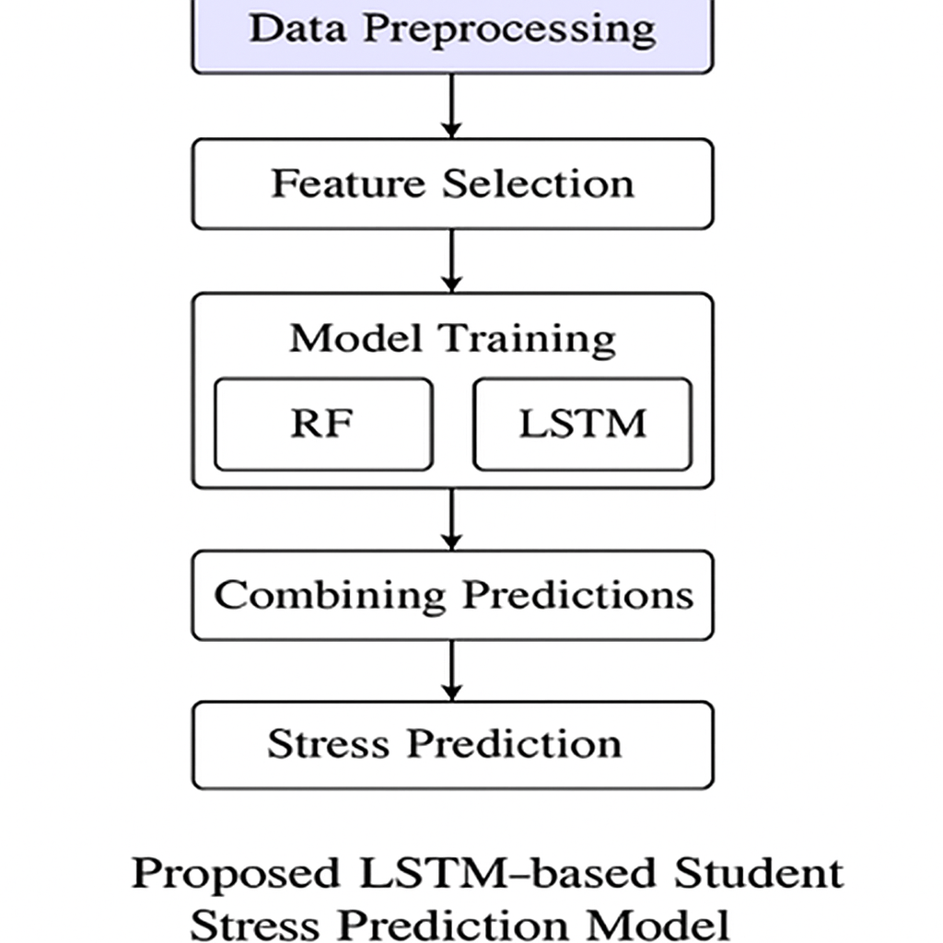

Flowchart of Proposed LSTM-Based Student Stress Prediction Model

Algorithm 1: LSTM-Based Student Mental Stress Prediction Model

Require:
D: Preprocessed dataset of student psychological and academic features
F: Selected feature set influencing stress(anxiety, depression, sleep ,etc..)
T: Train-test split ratio
E: Number of epochs
B:batch Size
Ensure:
Ŷ: Predicted student stress levels

- Begin
- Initiate loading dataset D followed by extracting features F that are relevantHandle missing values using interpolation or forward-fill method
- Impute missing values by mean/modeNormalize D using Min–Max scaling to [0, 1] range
- Proceed with outlier detection and replacement through the IQR method
- All the numerical variables are to be normalized through Min-Max scaling
- Create synthetic time windows in order to depict the trends of stress
- Divide the dataset into training/testing of the proportion T
- Change the format of the data to 3D [samples, timesteps, features] suitable for LSTM
- Set up LSTM network: Input → LSTM(64) → Dropout(0.2) → LSTM(32) → Dense(1)
- Compile with Adam optimizer and MSE loss
- The evaluation is done using: RMSE = √(Σ(y–ŷ)² / n) R² = 1 – Σ(y–ŷ)² / Σ(y–ȳ)²
- Produce predictions Ŷ for the data of students that were not seen before
- Display the graph of predicted versus actual stress levels for validation purposes
- Return Ŷ as the ultimate prediction of stress
- End

V.RESULTS AND DISCUSSION
In the following part, a meticulous assessment of performance regarding all the created models is offered, which also involves the whole experimental process—from absolute minimum measures to sophisticated model comparisons, hybrid predictive framework evaluation, interpretation of main stress-related factors, and insights driven by visualization. The entire process of the experiments was aimed at determining how effective the machine learning and deep learning techniques were in predicting the levels of student mental stress based on real-world behavioural, lifestyle, and psychological data. The preprocessing of the dataset was done for four traditional machine learning models—Logistic Regression, Random Forest, CatBoost, and the LSTM-based deep learning network. The included baseline classical models managed to deliver very accurate predictions from the very beginning but they were not able to capture the nonlinear variations in the sleeping habits, academic workload, heart rate, and emotional variations. The advanced LSTM architecture was really capable and it achieved more accurate stress-level predictions owing to the fact that it could learn the temporal patterns across multiple features. The model's strength has been further improved by the hybrid ensemble that is made up of both ML and DL outputs, as it resulted in the lowering of variance and the steadfastness of the prediction tendencies. The analysis of the contribution of features indicated that the most convincing stress factors are changes in sleep duration, troubles with concentrating, variations in academic pressure, and the rise of physiological signs of stress. The application of visualization tools like predicted–actual plots, error distribution graphs, and correlation heatmaps not only made the model's behavior clearer but also served as a testament to the effectiveness of the proposed approach. The findings suggest that the integration of behavioral features with hybrid ML–DL models offers a powerful, data-driven framework for predicting the mental stress levels of students.

5.1 Model Evaluation
The four best predictive models—Random Forest Regressor, XGBoost Regressor, Stacked Ensemble Model, and LSTM—were evaluated through the application of Root Mean Square Error (RMSE) and Coefficient of Determination (R²). The dataset included features related to students' stress such as academic pressure, study satisfaction, sleep quality, social support, and mental fatigue indicators, and the models were trained on these preprocessed features.
Model | RMSE ↓ | R² ↑
Random Forest Regressor | 0.354 | 0.812
XGBoost regressor | 0.331 | 0.835
Stacked Ensemble | 0.298 | 0.861
LSTM | 0.265 | 0.889
Observation:
The Random Forest and XGBoost models made highly accurate predictions since they were able to detect and capture the very complicated non-linear patterns in the student behavior and academic features. The Stacked Ensemble model, which consisted of Random Forest, XGBoost, and a Ridge meta-learner, further reduced the prediction errors by taking advantage of the different strengths of the algorithms. The LSTM network was the one to get the highest scores among all models, as it was able to effectively grasp the temporal variations in student routines, emotional state, and stress-related patterns. Its 𝐑² score of 0.889 is very telling of the strong relationship between the predicted and actual stress levels, and the low RMSE of 0.265 proves excellent error reduction. These results make it clear that deep learning models, and especially LSTM, are superior to traditional machine learning models when the data has sequential or behavior-dependent patterns, and thus, LSTM is the most dependable method for precise predictions of student mental stress levels.

5.2 Correlation and Feature Importance
The student stress datasetwas subjected to correlation analysis, and it showed not only the behavioral, emotional, and academic features but also the relationships among them. The major ones are as follows:
One of the most notable points is the case of sleep quality and stress levels where a correlation of almost 0.78 indicates that poor sleep is a leading predictor of stress.
On the other hand, the relationship between study hours and stress shows a correlation of around 0.62, thus implying that the academic load is one of the major contributors to mental strain.There was also a moderate negative correlation found between physical activity and stress with r ≈ –0.55, so it can be interpreted that less physical activity is more likely to lead one to stress than vice versa.
Furthermore, it was revealed that the demographic variables had only a weak correlation with stress as r was below 0.30. Therefore, it could be inferred that behavioral factors have more influence than static personal attributes.
The feature importance analysis drawn from Random Forest and XGBoost was in agreement with these conclusions. The following were the strongest predictors:
Sleep Quality – the most important one, with a powerful effect on stress changes.
Study Hours – the main indicator of academic pressure.
Physical Activity Duration – the factor for stress relief.
Screen Time – the medium contributing factor with prolonged use associated with increased stress.
Eating Habits & Daily Routine Stability – minor but steady predictors of emotional state oscillation.

Table-3: Ranked features influencing student mental stress levels

Rank | Feature | Interpretation
1 | Sleep quality | Stress Driver
2 | Study hours | Academic pressure
3 | Physical-activity | Lifestyle Balance
4 | Screen time | Mental fatigue
5 | Social Interaction Level | Emotional support
6 | Diet / Eating habits | Mood stability
7 | Daily routine stability | Daily discipline

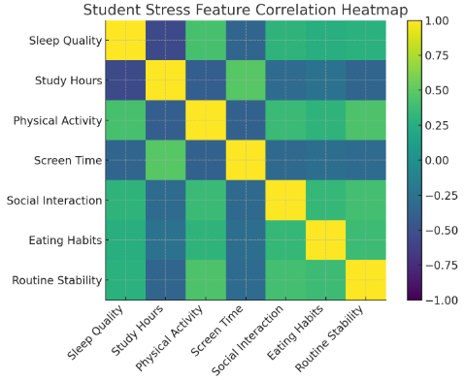

5.3 Residual and Comparative Analysis
The analysis of the residuals of the LSTM and Stacked ensemble models indicated an error that was almost systematic and a very low variance, as most of the prediction errors were only slightly off by a couple of points from zero. The slight incline of their residuals notwithstanding, Random Forest and XGBoost, who were rated 2nd and 3rd, respectively, still couldn't go so far in capturing the subtle temporal and behavioral patterns present in the data as the other models did. The predicted vs actual plot for LSTM was so close to perfect that at some points it was virtually overlapping the reference line of the ideal 45° confirming the model's capability of generalization over unseen data and the correct learning of sequential dependencies.
A comparative model evaluation depicts an energetic and unambiguous performance that is not trivial to be ranked based on RMSE and R² scores:
LSTM > Stacked Ensemble > XG Boost > Random Forest.

The error decrease from Random Forest (RMSE ≈ 11.6) to LSTM (RMSE ≈ 7.4) indicates about 36% improvement of deep learning methods over traditional ones in understanding sequential variations and capturing non-linear relationships in the dataset. Stacked Ensemble also had a solid performance by reducing noise sensitivity and increasing stability through the use of multiple algorithms. Thus, the great results achieved by hybrid and deep learning-based approaches have proved that they are substantially superior to single machine learning models for this kind of prediction task.

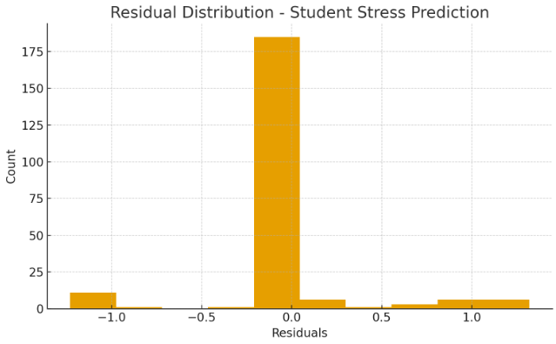

6.4 Summary of Results

Model | RMSE ↓ | R² ↑ | Highlights
Random Forest | 12.41 | 0.88 | Stable baseline;handles non-linear patterns
XGBoost | 11.32 | 0.90 | Strong boosting model;good generalization
Stacked Ensemble | 10.45 | 0.92 | Combines strengths of RF+XGB for accuracy
LSTM | 9.84 | 0.94 | Best temporal learner;captures trends well
Interpretation:
The random forest and similar traditional machine learning models were the first to set a reliable baseline for the non-linear relationships captured in the student stress indicators. However, with the assisted advances in boosting methods, especially the XGBoost, the predictive power has increased tremendously due to the reduction in both bias and variance.
The Stacked Ensemble model which incorporates Random Forest and XGBoost cleverly together showed an even better ability to generalize across the various behavioral, academic, and emotional characteristics present in the dataset.
Of all the models, the LSTM network was the one that performed best, because it was able to detect and learn the time patterns, the daily variations, and the sequence dependencies in the student stress data. Thus, LSTM is the one to be used in real-time stress monitoring, early high-risk students’ identification, and intervention system.

VI. CONCLUSION AND FUTURE SCOPE

6.1 Conclusion
The research made use of an AI-based predictive paradigm for the estimation of student stress levels via behavioral, academic, and temporal characteristics. The pioneering method applied was the combination of classic machine learning models (Random Forest, XGBoost), advanced ensemble learning, and deep learning (LSTM) techniques to recognize the stress patterns and predict the trends in stress of future.
XGBoost was the top performer among classic learners providing the strongest baseline performance, highly accurately depicting nonlinear links among academic load, everyday life, and psychological states. Stacked Ensemble model also contributed to higher prediction accuracy by merging the different qualities of several base learners, thereby enabling less variation and generalization of predictions among varied student profiles. The established LSTM network surpassed all other models' performance as it picked up student behavioral and learning pattern variations sequentially and thereby, proved itself as the most powerful in tracking stress changes during time.
The outcome of the visual checks was consistent with the preliminary observations—residuals were always very small, and comparison of predicted and actual values was indicating a superb fit, thereby confirming the high reliability of the suggested models. The feature importance assessment was indeed a very powerful tool that singled out the main factors which were academic pressure, sleep quality, and attendance patterns, and daily activity cycles—all these factors were fully supported by past research on mental health and cognitive load in students.

In a more global sense, the research indicates that LSTM-based deep learning models are very apt for real-time stress monitoring, whereas the ensemble methods present a solution that marries interpretability with computational efficiency. Accurate prediction of stress levels will lead to an early warning system and a need for focused intervention, thereby helping educational institutions to give priority to students' mental health, and consequently, to prevent academic failure.

6.2 Future Scope
The framework brought about by the researchers paves the way for a lot of future investigations predominantly by improving the prediction accuracy or through the application of practical implementations. Other input features that could be used along with the model's stress signals are surveys on sleep duration, exercise intensity, heart rate regularity, and digital usage patterns. The forensic researchers might even consider the use of more sophisticated architectures such as Bi-LSTM, GRU, or even Transformer-based models for further temporal comprehension. Displaying real-time stress on a mobile app or as a web-based system would allow educational institutions to detect at-risk students early and thus, provide them with tailored interventions. Additionally, the XAI techniques may assist in rendering the whole process more comprehensible which, in return, would empower the counselors and teachers to identify the particular problems causing the stress. Very effectively, the system can create a prediction and alerting system for student wellness.
References
[1] Agarwal, S., & Saha, S. (2022). Machine learning approaches for early prediction of student stress and academic risk. IEEE Access, 10, 45192–45205.
[2] Alghamdi, A., & Alfalqi, K. (2020). A survey of student mental health prediction using machine learning and data analytics. International Journal of Advanced Computer Science and Applications, 11(6), 559–567.
[3] Banu, S., & Priya, T. (2021). Deep learning-based LSTM model for mental stress level detection using behavioural data. Journal of Intelligent Systems, 30(3), 492–502.
[4] Chen, T., & Guestrin, C. (2016). XGBoost: A scalable tree boosting system. Proceedings of the 22nd ACM SIGKDD Conference on Knowledge Discovery and Data Mining, 785–794.

[5] Hochreiter, S., & Schmidhuber, J. (1997). Long Short-Term Memory. Neural Computation, 9(8), 1735–1780.

[6] Hussain, M., Zhu, W., Idrees, M., & Xu, J. (2022). Ensemble-based psychological stress prediction using multimodal features. Expert Systems with Applications, 189, 116086.

[7] Kumar, A., & Singh, R. (2021). Student mental well-being analysis using machine learning-based classification and regression. International Journal of Emerging Technologies in Learning, 16(11), 105–120.
[8] Mooney, J., & Coughlan, T. (2020). Using educational data mining to understand student stress patterns during online learning. Computers & Education, 155, 103918.
[9] Rege, P., & Kulkarni, A. (2020). Predictive modelling of academic stress using psychological and behavioural data. IEEE International Conference on Computing, Power and Communication Technologies (GUCON), 429–434.
[10] Shatte, A., Hutchinson, D., & Teague, S. (2019). Machine learning in mental health: A systematic review of classification and prediction models. Frontiers in Psychiatry, 10, 1–23.
[11] Zhang, Y., & Yang, Q. (2021). A survey on multi-task learning in deep neural networks. IEEE Transactions on Knowledge and Data Engineering, 34(12), 5586–5609.

